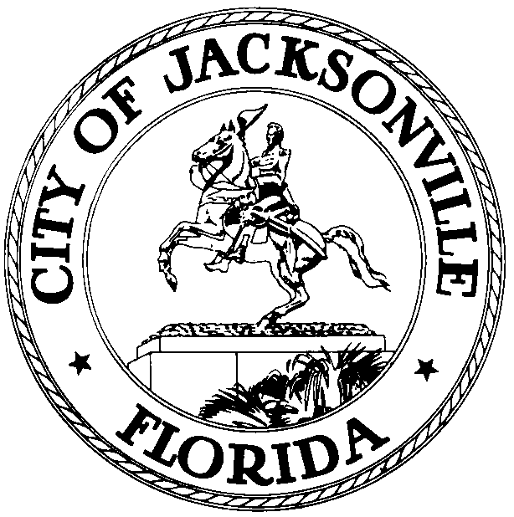

OFFICE OF THE CITY COUNCIL

DR. CHERYL L . BROWN 117 WEST DUVAL STREET, SUITE 425
DIRECTOR 4TH FLOOR, CITY HALL
OFFICE (904) 630-1452 JACKSONVILLE, FLORIDA 32202
FAX (904) 630-2906
E-MAIL: CLBROWN@COJ.NET

July 9, 2015
(5:00 P.M)

AMENDED NOTICE

M E M O R A N D U M

TO: Standing Committee Chairpersons
Council Members
Council Staff

FR: The Honorable Gregory B. Anderson, President- Designate
Jacksonville City Council

RE: July 1, 2015 through June 30, 2016 Standing Committee
Meeting Assignments, Dates, Times, Meeting Locations
_____________________________________________________________
Notice is hereby given that The Honorable Gregory B. Anderson, President - Designate, Jacksonville City Council sets the following meeting dates and times for the Standing Committees and Standing Committee Agenda Meetings. The Chairmen of the Jacksonville City Council will meet with the Standing Committee Members on the first and third week of each month in the Council Chamber, 1st Floor, City Hall at St. James, 117 West Duval Street, Jacksonville, Florida. (See individuals Committee information below for details on meeting dates, times, and locations.) These meetings will take place at the times listed below unless there is a holiday, upon which the meetings will be take place 24 hours after the holiday.

STANDING COMMITTEE SCHEDULE:

Finance Committee
Financial matters, including appropriations; budgets; budgetary transfers; taxes; fees; franchises; bonds; fiscal and investment policies; licensing; personnel; pensions; leases; Administration and Finance Department; Procurement Department; JEA financial issues; auditing; performance measurement and benchmarking; audits of the City and Independent Agencies; selection and retention of the auditor to perform the annual independent audit required by Section 5.11 of the Charter; TRUE Commission reports; and all related subjects.
Committee Members:
Bill Gulliford - Chair
Anna Brosche - Vice Chair
Danny Becton
Aaron Bowman
Lori N. Boyer
John R. Crescimbeni
Reggie Gaffney

Finance Agenda Meeting Location/Time:
First & Third Monday at 9:00 a.m.
Conference Room A – Suite 425
Fourth Floor, City Hall
117 W. Duval Street

Finance Committee Meeting Location/Time:
First & Third Monday at 9:30 a.m.
Council Chamber
First Floor, City Hall
117 W. Duval Street

Transportation, Energy & Utilities Committee

Matters relating to roads and streets; Fair Share Assessments; transportation; transportation planning; multimodal transportation issues; intelligent transportation systems (ITS); First Coast MPO; railroads; deregulation of electric utilities; ambulances; towing; vehicles for hire; public utilities or utility- related services; JEA (water and sewer operations, chilled water operations, and other non-budgetary issues, power generation and distribution), Water and Sewer Expansion Authority; Public Works Department; refuse collection; environmental services; public parking; Environmental Resource Management Department; landfills; Jacksonville Transportation Authority; Jacksonville Aviation Authority; Jacksonville Port Authority; service quality improvement and public satisfaction with government services; advanced communication and technology use and "e-government"; and all related subjects.
Committee Members:
Reginald Brown - Chair
Tommy Hazouri - Vice Chair
John R. Crescimbeni
Al Ferraro
Reggie Gaffney
Joyce Morgan
Scott Wilson

TEU Agenda Meeting Location/Time:
First & Third Monday at 1:30 p.m.
Conference Room A – Suite 425
Fourth Floor, City Hall
117 W. Duval Street

TEU Committee Meeting Location/Time:
First & Third Monday at 2:00 p.m.
Council Chamber
First Floor, City Hall
117 W. Duval Street

Recreation Community Development Public Health & Safety Committee
Matters relating to recreation; public housing; economic development; affordable housing; farms; forestry; fish and game; parks; zoo; international trade and travel issues; Sister Cities program; Jacksonville Public Library; Parks; Recreation and Entertainment Department; Agriculture Department; Jacksonville Economic Development Commission; Jacksonville Housing Commission; Jacksonville Housing Authority; Community Services Department; ad valorem property tax exemptions; historic preservation; community revitalization; Waterways Commission; vessels for hire; Urban Services Districts; the Neighborhoods Department; education and schools; Duval County School Board; literacy issues; higher education institutions and issues; military bases; personnel and affairs; base realignment and closure (BRAC) issues; veterans' issues; and all related subjects. Matters relating to the Jacksonville Children's Commission; child services; public safety; motor vehicle inspections; collections; crime victim services; Sheriff's Office; Fire and Rescue Department; emergency preparedness and civil defenses; hospitals; Health Department; human services; welfare; health; and all related subjects.

Committee Members:
Doyle Carter - Chair
Sam Newby - Vice Chair
Katrina Brown
Reggie Brown
Garrett Dennis
Al Ferraro
Matt Schellenberg

RCD Agenda Meeting Location/Time:
First & Third Tuesday at 9:00 a.m.
Conference Room A – Suite 425
Fourth Floor, City Hall
117 W. Duval Street

RCD Committee Meeting Location/Time:
First & Third Tuesday 9:30 a.m.
Council Chamber
First Floor, City Hall
117 W. Duval Street

Rules Committee

Matters relating to confirmation of nominations by the Council; Mayor and Sheriff; rules; laws; executive communications; resolutions; memorials; calendar; agenda; charter revision; governmental reorganization; City Council and School Board redistricting; elections; courts; consumer affairs; "J-Bills" and legislation before the Florida Legislature; and all unclassified subjects.
Committee Members:
Matt Schellenberg- Chair
Jim Love- Vice Chair
Anna Brosche
Doyle Carter
Garrett Dennis
Tommy Hazouri
Sam Newby

Rules Agenda Meeting Location/Time:
First & Third Tuesday at 1:30 p.m.
Conference Room A – Suite 425
Fourth Floor, City Hall

Rules Committee Meeting Location/Time:
First & Third Tuesday at 2:00 p.m.
Council Chambers
First Floor, City Hall
117 W. Duval Street

Land Use & Zoning Committee

Land use and zoning matters, including zoning; preservation; conservation; building codes; urban renewal; real estate; land use; land, water and wetlands, preservation; water supply issues; comprehensive planning; strategic planning; current planning; growth management and implementation of state statutes regarding same; Landscape Commission; Planning and Development Department; appeals from Planning Commission decisions; growth management; transportation concurrency; school concurrency; water supply planning; monitoring and implementation of the new State growth management laws; actively participate in amending and updating Jacksonville's Comprehensive Plan, including reviewing all text amendments and Future Land Use Map Amendments to the comprehensive plan; and all related subjects.
Committee Members:
Scott Wilson - Chair
Lori N. Boyer - Vice Chair
Danny Becton
Aaron Bowman
Katrina Brown
Jim Love
Joyce Morgan

LUZ Agenda Meeting Location/Time:
First & Third Tuesday at 1:00 p.m.
Conference Room A – Suite 425
Fourth Floor, City Hall
117 W. Duval Street

LUZ Committee Meeting Location/Time:
First & Third Tuesday at 5:00 p.m.
Council Chambers
First Floor, City Hall
117 W. Duval Street

ALL interested parties are invited to attend.
Please contact Legislative Services Division at (904) 630-1404 for additional information or correspondence or go to http://cityclts.coj.net/coj/ to access the latest Standing Committee Agendas.
.

GBA/lk/clb

xc: Council Members/Staff
Cheryl L. Brown, Director/Council Secretary
Dana Farris, Chief – Legislative Services Division
Carol Owens, Assistant Chief – Legislative Services Division
Jeff Clements, Chief, Research Division
Kristi Sikes, Chief, Administrative Services Division
Mayor’s Office
Office of the General Counsel
CITYC@COJ.NET
Electronic Notice Kiosk – 1st Floor City Hall
Public Notice System – City Council Web Page
Media Box
File Copy

